**Ramaiah Institute of Technology**

**Department of Computer Science & Engineering**

Subject: Finite Automata and Formal Languages Subject Code: CS45

Semester: IV Section: A, B, C & D

**Practice questions for UNIT-1**

**DFA:**

1. Construct DFA for Σ = {0, 1} which accepts strings starting with 2 0's & ending with 2 1's.
2. Obtain DFA that accepts all strings on Σ = {0, 1} that ends with 1 and do not contain 00.
3. DFA for L = {wbab | w ∈ {a, b}*}
4. L = {a2nb3mc | n ≥ 1 and m ≥ 0}
5. At least one ‘a’ and exactly two b’s.
6. Draw a DFA for the language accepting strings that doesn’t contain the substring ‘00’ over input alphabets Σ = {0, 1} ?
7. Construct DFA, which accept all the string over alphabets ∑ {0,1} where the **length of each string is exactly 2.**
8. Construct DFA, which accept all the string over alphabets ∑ {0,1} where the**length of each string is ≥ 2.**
9. Construct DFA, which accept all the string over alphabets ∑ {0,1} where the**length of each string is ≤ 2.**
10. Draw a DFA with sigma **∑ = {0, 1}**for the language accepting **strings containing at most two ‘0’.**
11. Design a DFA with sigma **∑ = {0, 1}**for the language accepting strings starting and ending with different characters.

**NFA/Epsilon NFA:**

1. Design a NFA without epsilon that accepts a string 10 or 1.
2. Design an NFA with input alphabet ∑ = {0, 1} that accepts all the strings that end with 01.
3. Design an NFA with ∑ = {0, 1} such that every string includes the substring 1101**.**
4. Construct an NFA with ∑ = {0, 1}, where each string must contain either “01” or “10**”**
5. Construct an NFA with ∑ = {0, 1} for the language L = {0m1n | m ≥0 and n≥1}.

**NFA to DFA Conversion:**

1. Draw an NFA that accepts all the strings ending with “1” over Σ {0,1} and convert this NFA to its corresponding DFA.
2. Convert the following NFA to DFA.

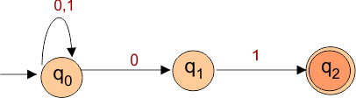

1. Convert the following NFA to DFA

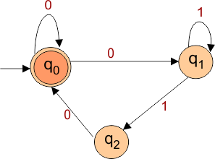

1. Convert the following Epsilon-NFA to DFA.

